**Q1.**–What are the major driving forces in behind evolution of Radio Communication Networks from 1G to 5G?

Starting from Networked mainframes, Standalone workstations LANs , internetworking and internet commercialization it became necessary to evolve as per rising demands. There are application driven networks which require advanced bandwidth hungry applications like videoconferencing, collaboration, media conferencing, It needed a hierarchical networks decision about network resource based on no of devices and distance from one other, Advanced application which needed greater capacity demands could not tolerate delays or congestions in thse and began to dictate the type of network needs.

1. Need of faster communication medium
2. Advanced technological developments
3. Needs of end user /customers to have
   1. Low cost rate
   2. High data rate / faster communication
      * Started with GPRS GSM Packet Radio Service
      * To Enhanced Data for GSM Evolution
      * WCDMS – Wideband code division multiple access
      * LTE – Long Term Evolution
   3. Better user communication
   4. Low latencies
   5. More services - voice only to sms mms , webmail,
4. Goals of a Service Provider to upgrade from 1G to 5G
   1. They wish to generate more revenues
   2. Provide service at Reduced cost price
5. Cost busters
   1. Capital cost
   2. Operation cost
   3. Spectrum
6. Major Cost source
7. Dramatic performance improvement in mobile communications standards have propelled mobile to become fastest adopted technology of all time
8. Mobile network infrastructure costs have dropped and performance have soared
9. Mobile data transmission speeds have skyrocketed
10. Consumer adoption has outpaced , mobile is connecting and empowering the consumers everywhere in the world
11. Continuous innovation and investment raised to evolve new technologies and faster speed
12. Small and medium sized enterprise adopt advanced mobile technologies are fastest growing
13. Mobile technologies are fuelling economic growth, driving recovery from global recession

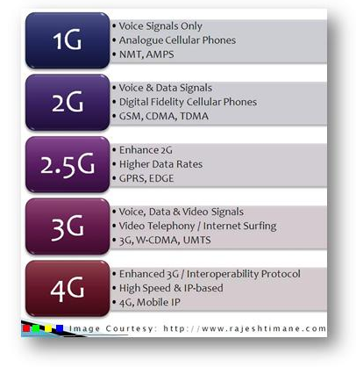

Above represents 1G to 4G evolution with the best of services offered and enhancements to the future generations.

**Q2. -**What is Packet switching technology used in 4G/5G communication networks?

* Packet Switching is routing of the data from source to destination digitally by network transmission system
* In this , the sender sends data in segments i.e. dissemble the data packet to be sent in chunks of same segments to the destination, in small packets, the network sends these packets broken down in segments and routes these packets in efficient way
* The receiver re-assemble all the data packets received and reconstruct the message at receivers end
* This offers enhanced QoS
  + Provides different priorities to different data flows to guarantee better performance
  + Like voice Communication, streaming, web browsing, emails
  + QoS depends on required bit rate, delay, jitter, bit error rate

OFDMA (orthogonal frequency-division multiple access), a technology in Wi-Fi 6, improves wireless network performance by establishing independently modulating subcarriers within frequencies. This approach allows simultaneous transmissions to and from multiple clients.

OFDMA is essentially a type of OFDM for multiple users. It allocates in both the time domain and the frequency domain, allowing for multiple users—even those with widely varying use patterns or data loads. By comparison, OFDM can allocate only sequentially.